

Practices for Secure Software Report

Table of Contents
Document Revision History 3
Client 3
Instructions 3
Developer 4
1. Algorithm Cipher 4
2. Certificate Generation 4
3. Deploy Cipher 4
4. Secure Communications 4
5. Secondary Testing 4
6. Functional Testing 4
7. Summary 4
8. Industry Standard Best Practices 4

Document Revision History

Version | Date | Author | Comments
1.0 | February 22, 2026 | Katie Baca Dempsey

Client



Developer
Katie Baca Dempsey

Algorithm Cipher

SHA-256

SHA-256 is part of the SHA-2 family of cryptographic hash functions, designed by the U.S. National Security Agency and published as a federal standard by National Institute of Standards and Technology. Given an input of any length, SHA-256 produces a fixed 256-bit (32-byte) hash value, typically displayed as 64 hexadecimal characters. Cryptographic hash functions work one-way; they cannot be reversed and the input cannot be discovered via the output.

The SHA-2 family was designed to replace earlier hash functions that were observed to no longer be secure, in part, due to collision vulnerabilities. A collision vulnerability is when two inputs hash to the same output. SHA-256 is used to protect passwords, for digital signatures, data integrity verification, and TLS/SSL certificates. Being irreversible and collision resistant ensures confidentiality of cryptographic services.

Certificate Generation

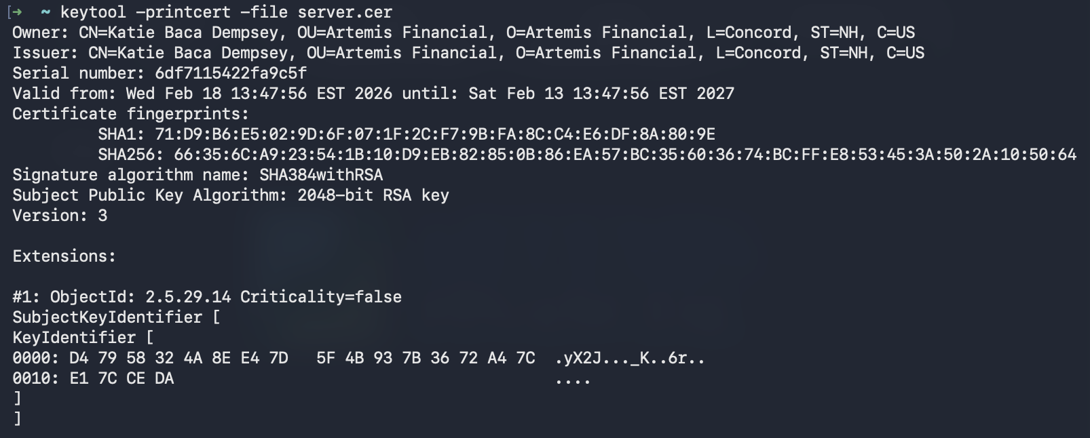

Deploy Cipher

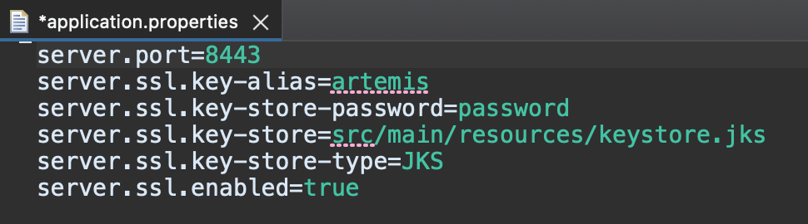
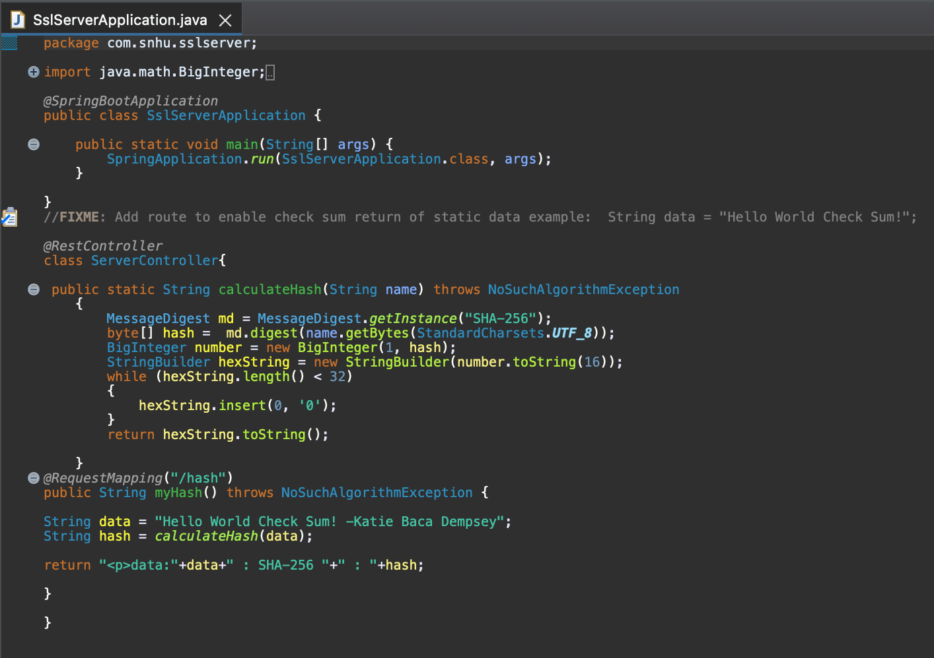

Secure Communications

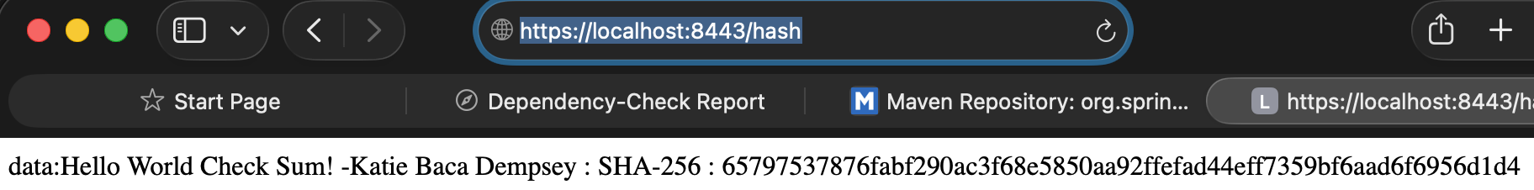

Secondary Testing

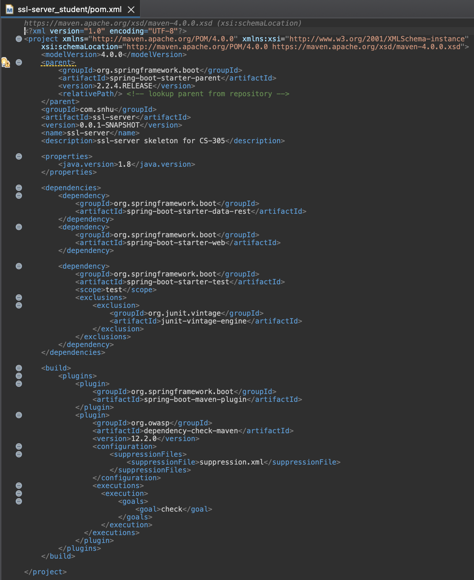

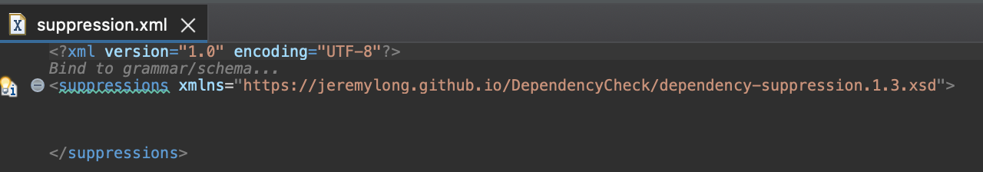

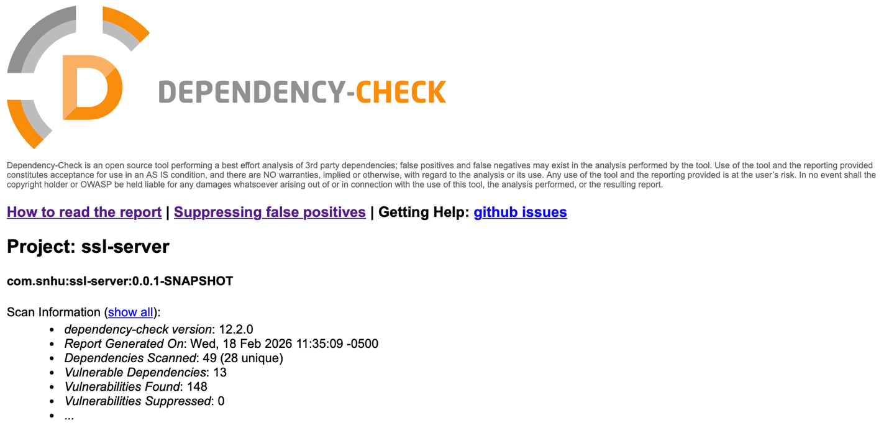

Functional Testing

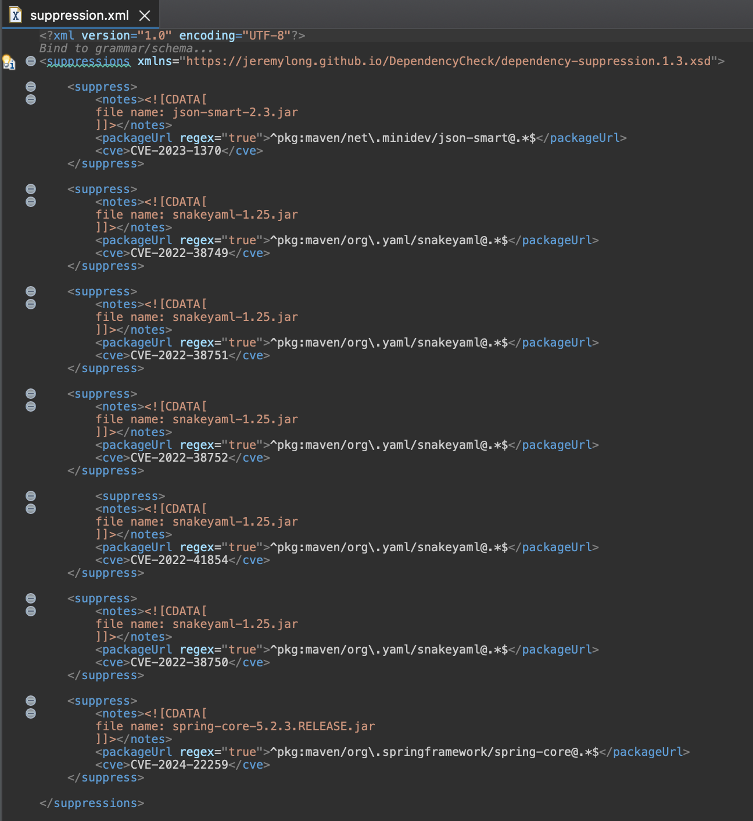
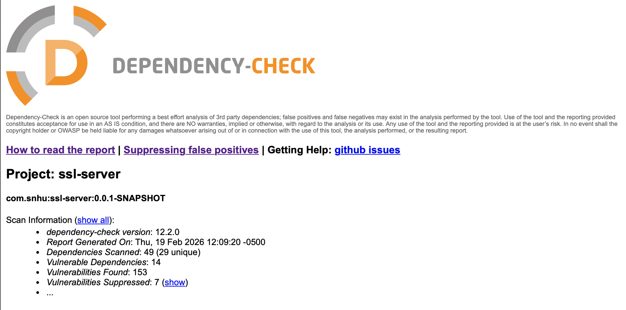

Summary

In order to implement cryptographic security, a checksum was added to SslServerApplication. The checksum utilizes the function of hashing information to confirm that during transit the information has not been altered and is in fact identical to what was originally sent.
Additionally, by denoting the use of port 8443 the website utilizes https for secure communication.

Initially running the dependency check highlighted identified vulnerabilities relating to dependencies within the software. Reviewing the information supplied regarding each vulnerability provides options for possible mitigation. The creation of the suppression file and populating it with vulnerabilities to eliminate from the check narrows down the report to vulnerabilities that can be resolved either via updating the dependency or by installing a patch.

Industry Standard Best Practices

It is vital to confirm that a user receives uncompromised data. Utilizing a checksum verifies that data being delivered to the user is identical to what was sent and thus has not been compromised.

In running the dependency check, reviewing that report and then narrowing down the vulnerabilities, a to do list is created. This to do list includes dependencies that should be updated or patched to resolve the identified vulnerabilities. Leaving known resolvable vulnerabilities in place is akin to giving hackers the code to the safe. Not only by law but by moral obligation, it is a developer’s job to protect secure information.

Wikimedia Foundation. (2026, February 21). SHA-2. Wikipedia. https://en.wikipedia.org/wiki/SHA-2
Wikimedia Foundation. (2026a, February 16). Cryptographic hash function. Wikipedia. https://en.wikipedia.org/wiki/Cryptographic_hash_function
Owasp Foundation, The Open Source Foundation for Application Security: OWASP Foundation. OWASP Foundation, the Open Source Foundation for Application Security | OWASP Foundation. (n.d.). https://owasp.org/
National Vulnerability Database. NVD. (n.d.). https://nvd.nist.gov/vuln
Nistir 8202 blockchain technology overview Dylan Yaga Peter Mell Nik Roby. (n.d.). https://nvlpubs.nist.gov/nistpubs/ir/2018/nist.ir.8202.pdf
GeeksforGeeks. (2025, July 23). What is strong and weak collision resistance in cryptography? https://www.geeksforgeeks.org/computer-networks/what-is-strong-and-weak-collision-resistance-in-cryptography/
John Worthley (2026, February 2). What is the use of port 8443?. Stack Overflow. https://stackoverflow.com/questions/61760786/what-is-the-use-of-port-8443

